**[This](https://github.com/udacity/reactnd-UdaciFitness-complete/tree/1faffa1c2df4775c3f4fb1dc7460faca86b084fe" \t "_blank)** is where we left off in the last lesson.

In the last lesson, we learned to use the following components:

* [**Slider**](https://facebook.github.io/react-native/docs/slider)
* [**ScrollView**](https://facebook.github.io/react-native/docs/scrollview#docsNav)
* [**FlatList**](https://facebook.github.io/react-native/docs/flatlist)

We also made use of destructuring in the last lesson: const { getIcon, type, ...rest } = metaInfo[key]. Here, we're getting the property getIcon and type off the object returned from metaInfo[key]. That object also has a [**bunch of other properties**](https://github.com/udacity/reactnd-UdaciFitness-complete/blob/f9b86f4b8fd5c2c2c89cfa32552b67f76a48fcf3/utils/helpers.js)(i.e. max, unit, etc.) What ...rest is doing is copying the rest of those properties into a new object called rest.

Let's take a look at a similar example:

**const** user = {

name: 'Jane Johnson',

age: 35,

occupation: 'Software Engineer',

employer: 'CompanyA'

}

**const** {name, ...rest} = user;

console.log(rest);

*/\**

*Prints*

*{ age: 35,*

*occupation: 'Software Engineer',*

*employer: 'CompanyA' }*

*\*/*

**Performant Lists**

View

If you have a list inside of a View component:

* cannot scroll because the view is confined to area on the screen.

ScrollView

If you have a list inside of a ScrollView component:

* rendering each item regardless of whether a user can see it or not.

FlatList

If you have a FlatList:

* need to pass in data, which is the list of items we want to loop over.
* need to pass in renderItem, which will be responsible for rendering each item.
* rendering the items the items the user can currently see.

**[[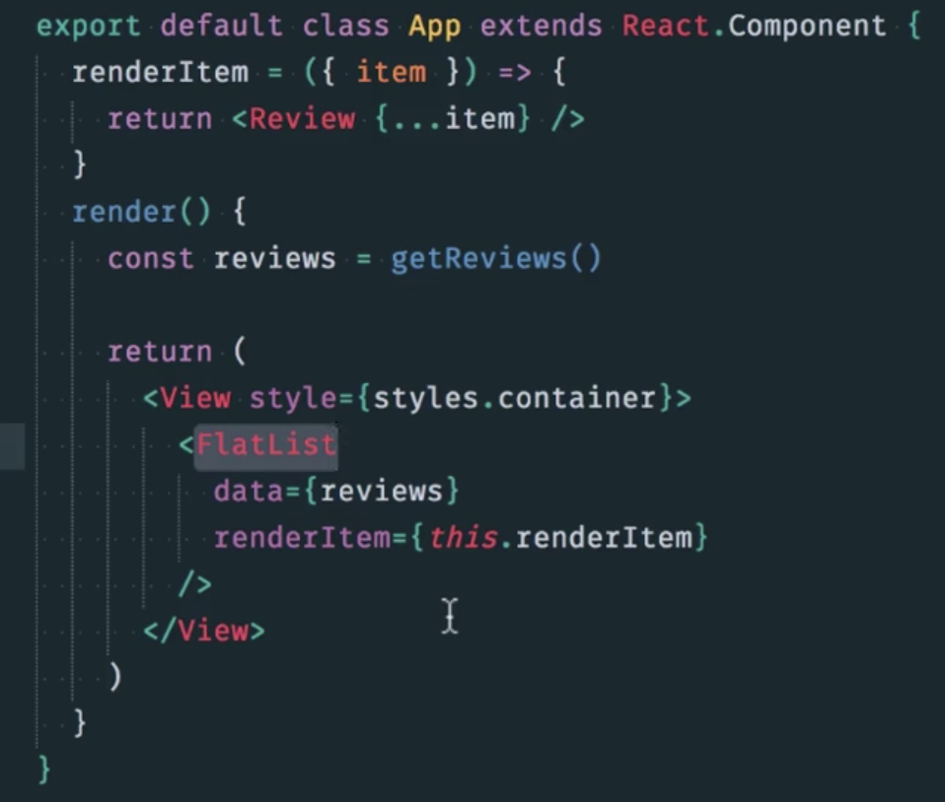](https://classroom.udacity.com/nanodegrees/nd019/parts/1187639a-82e2-4dd8-9d7b-477af14e5dd7/modules/1144e56b-57db-4156-bdb5-5c80304bc7dc/lessons/76fb00ee-ac2b-41f9-a7ed-1aa42f0a76bf/concepts/bcf8ae91-4388-429d-a84f-f5d82152707a)](https://classroom.udacity.com/nanodegrees/nd019/parts/1187639a-82e2-4dd8-9d7b-477af14e5dd7/modules/1144e56b-57db-4156-bdb5-5c80304bc7dc/lessons/76fb00ee-ac2b-41f9-a7ed-1aa42f0a76bf/concepts/bcf8ae91-4388-429d-a84f-f5d82152707a)**

**[FlatList](https://classroom.udacity.com/nanodegrees/nd019/parts/1187639a-82e2-4dd8-9d7b-477af14e5dd7/modules/1144e56b-57db-4156-bdb5-5c80304bc7dc/lessons/76fb00ee-ac2b-41f9-a7ed-1aa42f0a76bf/concepts/bcf8ae91-4388-429d-a84f-f5d82152707a)**

renderItem is mapping over each item in the reviews object.